Army Cricket Association

President: Major General James Illingworth OBE

Chairman:  Brigadier Jonathan Bartholomew OBE  COS to COM(L)  Head of Land Domain HQ  MOD Abbey Wood, #2127 Maple  BRISTOL  BS34 8JH  Civ: 030 679 8896  Mil: 9679 88960  Mob: 07788 566399  Jonathan.Bartholomew359@mod.gov.uk |  | Secretary:  Lieutenant Colonel (Retd) Mike Thornley  Army Sports Control Board  The Mackenzie Building  Fox Lines, Queens Avenue  ALDERSHOT  Hampshire GU11 2LB  Civ 01252 787074  Mil: 94222 7074  Mob: 07786 094178  mthornley@ascb.uk.com  https://cricket.armysportcontrolboard.com
 |  | 20 Feb 20

GUIDANCE FOR THE ASSURANCE OF CRICKET IN THE ARMY – THE ARMY CRICKET ASSOCIATION (ACA) SPORT SAFETY MANAGEMENT PLAN (SSMP)

A. Army Sport Control Board Directive.
B. AGAI Volume 1 Chapter 5 Sport (updated June 2017).
C. Guidance for the Assurance of Army Representative Sport ASCB/ACOS/Pol/23/04 dated 21Jun 18.
D. Army Cricket Handbook (ACH) 2019 (due to be updated Apr 20).
E. JSP 375 Pt.1 (V1.0 Jun 17) – Management of Health and Safety in Defence: Directive (Jun 17).
F. JSP 660 – UKAFSB Guidance and Direction.
G. Army Command Standing Order (ACSO) No 3216 – The Organisation and Arrangements for the Management of Safety and Environmental Protection in the Army. Issued May 2018.
H. MCC Laws of Cricket.
I. ECB Directives for bowling, fielding, young persons and fitness of ground due to weather and light.
J. CB and PCA Guidance: Head Protectors / Helmets.

Introduction

- Ref A, provides direction for the conduct and delivery of sport in the Army. This includes the assurance, compliance and governance of sport in accordance with Ref B. Ref C provides further guidance and specifically tasks the Chairman of the Army Cricket Association (ACA) to:

  - Ensure the delivery of the Cricket, through the ACA Executive Committee, is in accordance with the policy and guidelines stipulated by England Cricket Board together with the direction in Ref C.

  - Ensure that cricket has an effective assurance mechanism to provide a safe environment.

Sports Safety Management Plan (SSMP)

- This document provides a framework SSMP for Cricket within the Army and identifies key roles and responsibilities for those personnel involved in the delivery, assurance and governance of cricket, within their organisation. As such it is a supporting document to the Army Cricket Handbook (Ref D) which is published annually (or as required).

Unit Level Cricket

- In common with other sports, the Chairman of ACA is not accountable for the conduct of unit (and below) level cricket, which remains a Chain of Command responsibility. This document will, however, provide guidance and direction to assist those who are responsible at unit level. ACA will endeavour to ensure that any specific guidance on safety from the NGB is cascaded down through the ACA structure to Corps and Units in order to assist them with meeting their responsibilities.

Risk Assessment

- All Cricket activity is to be risk assessed and, where necessary, recorded by the nominated / appointed person managing the activity. Appropriate control measures must be implemented before any activity takes place utilising Chapter 4 to Ref E as guidance (if required). A risk assessment considers what could cause harm to people, in order to assess whether enough precautions have been taken in order to prevent or reduce the likelihood of any harm occurring. Risk assessments need not be complicated, and provided a few simple steps are followed, are relatively straightforward to complete. A generic risk assessment for cricket is at Annex A and must be completed / used for all Corps and Army level tournaments.

General Provisions

- The following provisions apply to all representative cricket matches:

  - One nominated person has overall responsibility as the OIC (this will normally be the Team Manager or Captain or, in some cases, the Tournament Referee).

  - Wherever possible there should be at least one qualified emergency first aider at the venue. Where this is not possible then the OIC should be aware of the procedures for contact local assistance.

  - Team managers or coaches are to ensure that the Army Cricket Association issued first aid kits are available for every match, both home and away.

  - Main Army Pitch locations should have a Level 1 Cricket First Aid Kit available. These pitch locations are as follows:

    - Aldershot (ACA Responsible).
    - Tidworth (Infantry Responsible).
    - Larkhill (RA Responsible).
    - Chatham (RE Responsible).

  - All fixtures and overseas visits are to be authorised by the Operations Officer, ASCB and the Chain of Command in accordance with Ref F.

Chairman’s Safety Commitment

- The Chairman of ACA will, on an annual basis, account for safety performance, measured against JSP 815 (Defence Health, Safety and Environmental Protection – HS&EP) criteria. This will encapsulate all safety activities such as meetings and assurance visits, and also forms the basis for the following safety commitments:

  - To prevent fatalities and to minimise injury to personnel playing cricket in authorised UKAF ACO events.

  - To manage and update (as necessary) the ACA SSMP.

  - To comply with higher-level safety regulations from Defence and England Cricket.

  - To supervise and control ACA safety related activities.

  - To investigate and learn from any incidents and accidents.

Safety Assurance

- The ACA will strive to improve safety performance and to minimise the risk of an accident or injury as far as is reasonably practicable. There are two elements that enable the ACA to meet this intent:

  - Planning.

    - Representative Fixtures. Team Managers / Captains are responsible for planning and arranging formal representative fixtures whilst also ensuring that the appropriate safety measures are in place. All fixtures are to be authorised by either the Operations Officer from Army Sports Control Board (ASCB) or the Chain of Command (normally the Commanding Officer).

    - Major Events. The ACA Committee is responsible for planning the ACA major events and ensuring that appropriate safety measures are in place. Where there is a nominated Tournament Referee they will be responsible for overall safety.

  - Delivery and Execution. Those responsible for the planning of events and Team Managers and coaches are responsible for the safe delivery of cricket. The lead for on field safety will always be the match officials. Where the match is played at a non-military establishment, the event organiser or Team Manager is to ensure that appropriate Health and Safety measures are discussed with the host and put in place. During the match the event organiser is responsible for managing any potential safety issues which should be addressed at the earliest opportunity.

- ACA AD Safety will conduct 1st Party Sports Safety Assurance by completing a Self-Assessment Questionnaire annually. The Self-Assessment Questionnaire will be reviewed annually by the ACA Chairman.

NGB Insurance Liability

- The NGB do not provide any insurance liability as part of the affiliation; this is the responsibility of clubs and individuals. Umpires require their own insurance cover. This is detailed in para 15.g.

Managing Risk

- The ACA will use the following five steps to assess risks prevalent whilst conducting on-duty cricket activities:

  - Identify the hazards.

  - Decide who might be harmed and how.

  - Evaluate the risks and decide whether existing control measures are adequate or whether more should be done.

  - Record the findings.

  - Review the assessment and revise it if necessary.

- While the generic Risk to Life (RtL), for cricket activities is LOW, there is one potentially HIGH risk area which is significant injury to a competitor. This risk will be managed by ensuring that:

  - All activities are fully risk assessed.

  - Ensure all players are fit to play the game (physically fit and injury free).

  - Appropriate medical provision is in place (on and/or off site). Note that England Cricket advocates the availability of Automated External Defibrillators (known as AEDs or Defibrillators) within all Clubs and facilities although these may not always be available.

  - Umpires, captains, managers and / or players should inspect the pitch / ground prior to play to ensure that it does not present a hazard. Inspection of the playing surface reduces the possibility of that being the cause of the injury but does not remove it entirely.

  - Umpires control the game and ensure that dangerous play is not permitted.

  - Players act within the rules (and spirit) of the game and do not cause injury to others or themselves due to reckless behaviour.

ACA Safety Management Responsibilities

- Chairman. The Chairman UKAF ACA has overall responsibility for safety within Army Cricket, including the endorsement of the SSMP. Specifically he / she is to:

  - Ensure that all personnel involved in the organisation, management and participation of Army Cricket sponsored events comply with the extant Defence and NGB guidance and, specifically, to this SSMP.

  - Ensure a review of all dynamic risk assessments and post-accident reporting is undertaken at least annually.

- ACA AD Safety. ACA AD Safety is responsible for providing advice and guidance to the Chairman, the Committee and throughout the Army cricketing community. They are specifically responsible for:

  - Reviewing and updating the SSMP as necessary.

  - Conducting 1st Party assurance (as outlined in Para 8).

  - Ensuring links with UKAFACO and the NGB are maintained.

  - Collating any AF 510s that are submitted as a result of accidents or incidents.

  - Conducting specified tasks as contained in the ACH and / or directed by the Chairman.

  - Conducting pitch inspections in accordance with ECB guidance (Ref I).

- Event Organisers, Team Managers/Captains. Event organisers, Team Managers/Captains are to:

  - Ensure that a venue specific risk assessment has been completed.

  - Brief all participants using the venue specific risk assessment alongside any additional hazards identified in the risk assessment.

  - Ensure communications are available for contact with emergency services and first aid equipment is at hand commensurate with the activity being undertaken.

  - Ensure that, in the event of an incident, AF510’s are completed and distributed in accordance with Para 17.

- Umpires. It is important that cricket matches are controlled and managed by a qualified umpire wherever possible. Junior or, in extremis, unqualified umpires are to be provided with guidance by the senior umpire at the event to ensure that, as a minimum, the safety rules are fully understood. The umpire’s responsibilities in terms of pitch inspection and safety of players is recorded in the laws and the annexes issued each year as part of the laws, directives and guidance (further detail is contained in Ref H). Umpires duties, in relation to the safe delivery of sport are:

  - Pitch Assessment. The umpire is to ensure the pitch is fit for play by confirming that:

    - Pitch Assessment to be judged by umpires in accordance with ECB Policy for usability before and during match.

    - In the event of an unsuitable pitch then a pitch report is to be completed and returned to AD Safety.

  - Player Safety. The umpire is to ensure that players are safe at all times and understand the key safety rules for cricket and, in particular, the points listed below.

  - Helmet Wearing. When batting against a fast bowler, fielding close to wicket or standing up when keeping wicket it is advised that a helmet is worn. Under 18 players must wear a helmet at all times when batting, fielding close to wicket or standing up when keeping wicket. Helmets must adhere to the ECB Guidance which can be found here: ecb-concussion-in-cricket/helmets. Further guidance is contained in Ref J.

  - Concussion. The MCC has now updated their advice on concussion in cricket. This is reflected in an online module that coaches, managers and umpires should go through before the start of the season. The module, which is a layman’s guide on how to deal with concussion in the game, is available via the recently redesigned Lord’s website, and aims to raise awareness on the risks of playing on after concussion. It is intended for everyone involved in the game, but specifically aimed at the grass roots level of the sport. This includes players, coaches, umpires and other officials.
The module also directs the user to information from Governing Bodies, who provide further details and also the relevant regulations in terms of helmets in the user’s respective countries.
It covers what signs and symptoms to look out for if a player is concussed, what course of action to take and how to manage the game from a Laws and regulations point of view, whilst also aiming to retain the Spirit of Cricket. It also stresses that not only batsmen are at risk of concussion, but wicketkeepers, bowlers and fielders too.” The ECB Concussion Module can be found here and should be seen by all those involved with safe management of the game (Officials, Managers, Coaches and Captains): https://www.ecb.co.uk/concussion-in-cricket/helmets. Fact sheets on Concussion for Umpires and Coaches are also attached at Enclosures 1 and 2.

  - Fast Bowling. Fast bowling is a part of cricket however the bowling must be safe. Any ball that passes the batsman on the full above the waist line ie without bouncing is classed as a “Beamer” and is dangerous. Bowlers will be penalised for this action. Bouncers are to be limited to 1 per over for safety reasons.

  - Fielding Techniques. Wherever possible, players should be trained by an ECB qualified coach in the correct fielding techniques. This will help to reduce the risk of injury.

  - Insurance. All UKAF ACO Umpires must be members of the ECB ACO so that they are covered by the ECB ACO insurance scheme. If units are using paid civilian umpires for matches these umpires must also be members of the ECB ACO so that they have the relevant insurance coverage for matches.

- Competent Medical Authority. The Competent Medical Authority (CMA) is a member of the ACA Executive Committee. This post is responsible for providing safety related medical advice to the Chairman and to the wider ACA as required.

- Accident Incident Reporting. In the event of an accident/incident leading to injury of a participant in the activity, or a member of the public as a consequence of the activity, the event organiser is to ensure post-accident reporting is undertaken in accordance with Annex H to Ref G. All reportable accidents, injuries and near misses (sporting or otherwise) are to be reported to the Army Incident Notification Cell (AINC) using Army Form 510. If an incident is reported to an activity OIC, then it is the OICs responsibility to generate the AF510. Otherwise, it is an individual’s responsibility to ensure that an AF510 is completed when they return to their unit. In the case of serious injury, initial notification is to be made with AINC without delay using one of the means below:

- Telephone: 96770-3661 or (+44) 03067 703661.
- Fax: 94393-6889 or (+44) 01264-886889.
- DII: Army LF-CESO-AINC-mailbox (MULTIUSER).
- E-Mail: ArmyLF-CESO-AINC-Mailbox@mod.uk.

- A blank template for the 510 is enclosed. Copies of all Army Form 510s are to be forwarded to the ACA AD Safety (copy to the ACA Secretary) where they will be retained. The forms will be used as part of the annual review.

- Individual Competitors. All individuals participating in Army Cricket have a responsibility for their own personal safety, together with that of their fellow competitors and the general public. Although all reasonable steps will be taken by event organisers and team managers to mitigate any associated risk there will always be a residual risk of injury. Individuals are therefore to comply with the following:

  - Personal Fitness and Medical Conditions. Personnel with pre-existing injuries or medical conditions that may impact on their ability to take part in the training or match must declare that condition to the event organiser or their team captain.

  - Personal Equipment. All equipment and clothing worn or used by personnel playing cricket must be in good condition and fit for its purpose.

- Ensuring that Army Cricket is carried out safely is a significant responsibility. ACA requires all personnel involved in the playing and administration of cricket to play their part in delivering a safe environment; both on and off the pitch. Ultimately, safety is not about prohibiting enjoyment of the game but about enhancing it. The direction contained within this SSMP is to be adhered to with immediate effect by all those involved with Army Cricket. Corps representatives are to ensure it is cascaded down through the Chain of Command to their units and individual players.

{signed electronically}

A J Rennie
WO2
ACA AD Safety / Secretary UKAF ACO
for Chairman ACA

Distribution:

UKAF ACO Committee & website
ACA – for Committee & website
Corps Cricket Chairmen / Secretaries
ASCB – Director & ACOS Assurance

Annex A. Generic Risk Assessment for Army Cricket.

Enclosures:

1. ECB Concussion Factsheet (Umpires).
2. ECB Concussion Factsheet (Coaches).
3. AF 510 Blank template. (Separate attachment).

Intentionally blank

GENERIC RISK ASSESSMENT FOR ARMY CRICKET ANNEX A

 |  | MOD Risk Assessment Form |  | MOD Form 5010
Establishment /Unit/Ship:  Army Sport Control Board |  |  |  |  | Assessment Ref:  Army Cricket | Date:
Section/Department:  Army Cricket Association (ACA) |  |  |  |  | Assessment Type  (Note 1) tick as appropriate
 |  |  |  |  | Specific | Generic
Activity/Process:  Army fixture and League matches take place throughout the season. A Tournament Referee will be appointed to run major competitions and each team has an appointed manager (or assistant manager) who will oversee all aspects of the match. Matches take place at a variety of grounds both civilian and those belonging to the 3 Services. The appointed officials will always have the final say on any safety matter. |  |  | Who is at risk:
 |  |  | All staff:
 |  |  | Operators and/or maintenance staff:
 |  |  | Visitors, vulnerable groups, public, etc. :
Ref | Hazard |  |  |  |  |  | RA Required
1 | Travel to/from Matches |  |  |  |  |  | X
2 | Ground |  |  |  |  |  | X
3 | Players/Officials/Equipment |  |  |  |  |  | X
4

Likelihood |  |  |  |  |  |  |  | Risk Matrix
Common, regular or frequent occurrence. |  |  |  |  |  | 3 |  | 3 Med |  |  |  | 6 High |  |  |  |  | 9 High
Occasional occurrence. |  |  |  |  |  | 2 |  | 2 Low |  |  |  | 4 Med |  |  |  |  | 6 High
Rare or improbable occurrence. |  |  |  |  |  | 1 |  | 1 Low |  |  |  | 2 Low |  |  |  |  | 3 Med
Severity |  |  |  |  |  |  |  | 1  Minor injury or illness. |  |  |  | 2  Serious injury or illness. |  |  |  |  | 3  Fatalities, major injury or illness.
Hazard  Ref | RISK Associated with Hazard  (How people may be harmed – type of injury or ill health) |  |  |  | Existing Control Measures  (Note 2) |  |  |  |  |  |  |  |  | Risk Rating | Additional Controls Required  (Note 2) |  |  |  |  | Review frequency  (Note 3)
1 | Travel to/from venue |  |  |  | - Where military transport is provided then JSP800 is to be adhered to. |  |  |  |  |  |  |  |  | 1 x 2 | Nil |  |  |  |  | 2 yearly
2 | Ground - injury from ground equipment. Wet pitches |  |  |  | - The ground authority is responsible for preparing the ground and clearing their equipment away prior to match.  - Umpires carry out pre-match inspection  - ECB directives on fitness of ground and light are followed.  - Ensure Ground has a first aid kit available. |  |  |  |  |  |  |  |  | 1 x 2 | Nil |  |  |  |  | 2 yearly
3 | Players/Officials/ Equipment –Injury risks |  |  |  | - Young Players (Under 18) to use protective equipment as per ECB Guidelines.  - All players to ensure that kit is in good state of repair.  - Team coach / captain is to ensure that the team has an issued first aid kit available.  - Standard safety kit for the role to be worn. Keeper pads, batting gloves etc.  - Advisable for additional protection eg helmets shin pads to be worn for close fielding positions  - Provision to be made for scorers to be under cover and comfortable during the match. heaters, fans etc  - Fluids to be available to all for duration of the match and breaks to be taken at suitable intervals in accordance with the weather conditions.  - Players to warm up before and warm down after match to reduce risk of injury.  See Refs I, J & K for further detail. |  |  |  |  |  |  |  |  | 1 x 2 | Nil |  |  |  |  | 2 yearly
Assessor |  |  |  |  |  |  |  |  | Manager (Note 4) |  |  |  |  |  |  |  |  | Overall Activity/Process Risk Rating
Name: |  |  |  |  |  |  |  |  | Name:
Rank/Grade: |  |  |  |  |  |  |  |  | Rank/Grade:
Line Manager Assessment Review
(Note 3 and 4)
Date: |  |  |  | Date: |  |  |  |  |  | Date: |  |  |  |  |  | Date:
Name: |  |  |  | Name: |  |  |  |  |  | Name: |  |  |  |  |  | Name:

Notes:

- If using a ‘Generic’ risk assessment, Assessors and line managers are to satisfy themselves that the assessment is valid for the task and that all significant hazards have been identified and assessed. If additional hazards are identified they are to be recorded and attached to the Generic assessment.

- Only a reference or simple description of the control measures is required. If the risk assessment identifies the need for additional control measures, the hazard will need to be reassessed once the additional controls have been implemented.

- Risk Assessments are to be reviewed:
- at a frequency proportional to the risk (e.g. high risk – 6 monthly; medium risk – annually; low risk – every 2 years)
- where required by local instructions/procedures;
- if the safe execution of the activity relies on stringent supervision and/or adherence to a safe system of work;
- if there is reason to doubt the effectiveness of the assessment.
- following an accident or near miss.
- following significant changes to the task, process, procedure, personnel or line management.
- following the introduction of more vulnerable personnel.
- If a “Generic” assessment then prior to use.

- Line managers are to note that they are responsible for production of the risk assessment and that they are signing to indicate that the risk assessment is suitable and sufficient and they consider the risks to be acceptable.

High | Common, regular or frequent occurrence. | 3 | 3 Med | 6 High | 9 High
Medium | Occasional occurrence. | 2 | 2 Low | 4 Med | 6 High
Low | Rare or improbable occurrence. | 1 | 1 Low | 2 Low | 3 Med
Risk Matrix  Likelihood X Severity |  |  | 1 | 2 | 3
 |  |  | Minor injury or illness. | Serious injury or illness. | Fatalities, major injury or illness.
 |  |  | Low | Medium | High

High | Improve control measures; consider stopping work. Conducting work at this level of risk is to be reported up the Line Management / Command chain.
Medium | Review control measures and improve if reasonably practicable to do so, consider alternative ways of working.
Low | Maintain control measures and review regularly or if there are any changes.

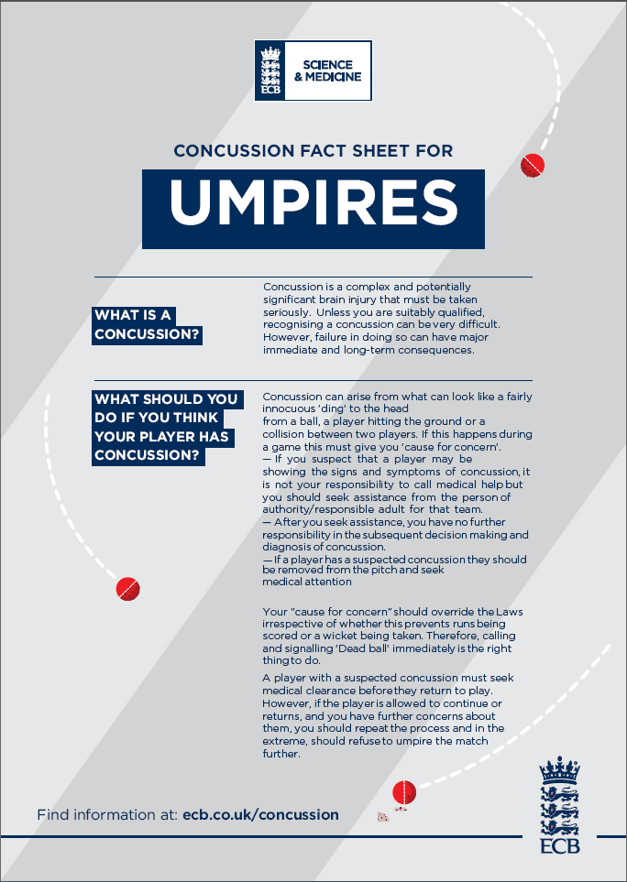
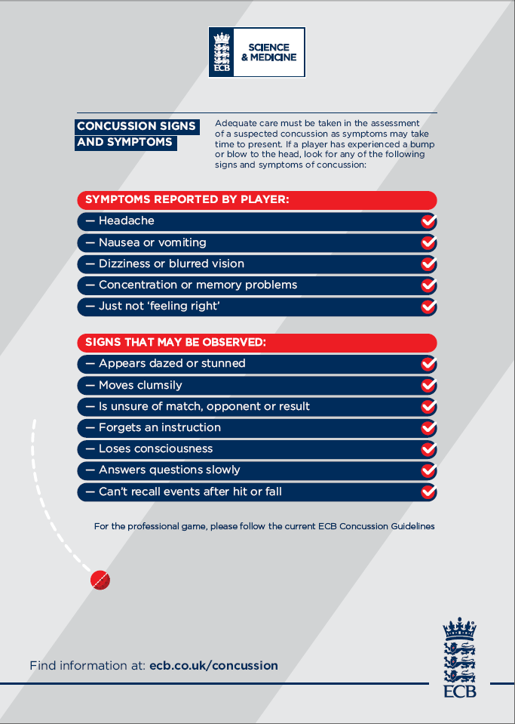

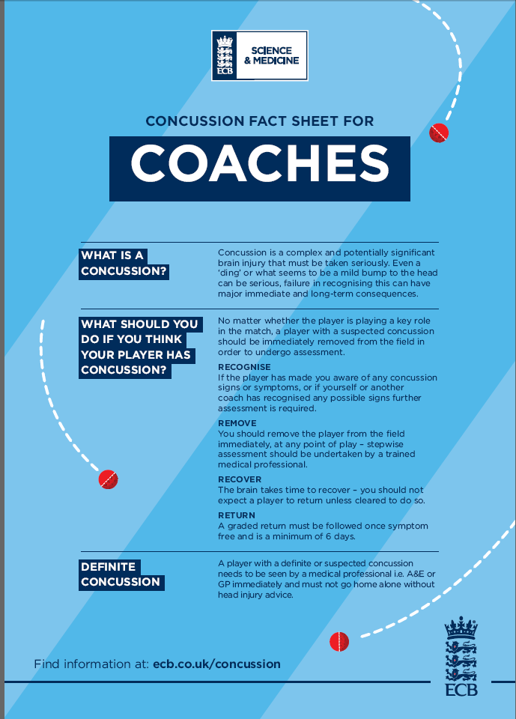
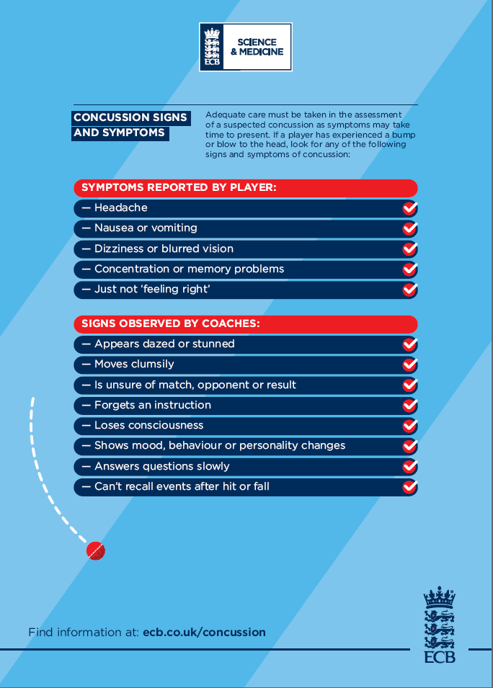

The extant version is available on the ASCB website https://armysportcontrolboard.com/wp-content/uploads/2018/12/20180917-ASCB_Directive_Sep_18.pdf. A new version is pending.
Representative level includes Corps and Army representation.
England Cricket Board (ECB) is the National Governing Body (NGB) for Cricket.
Major events include the Inter Corps Power Cup, Inter Corps T20 Comp, Army Major and Minor Unit Competition and UKAF events when hosted by the Army.
The minimum standard for an umpire is ‘Stage 1 & 2’ - courses are run annually through the ASPT and all officials are managed by UKAFCA ACO.
England Cricket guidance for players and cricket pitches is available from the England Cricket Board and is also contained within the Army Cricket Handbook (Ref D).

